Sunday – August 16, 2020
Lectionary readings
Genesis 45:1-15 Joseph is reunited with his brothers
Psalm 133(VU 856) How pleasant it is when God’s people are together
Romans 11:1-2a, 29-32: God has not rejected the Hebrews
Matthew 15: (10-20) 21–28 A Canaanite mother challenges Jesus

Welcome: Words of introduction and lighting of the Christ Candle.
Hymn: Joyful, Joyful We Adore You * (VU 232)
Joyful, joyful we adore you God of glory life and love; hearts unfold like flowers before you, opening to the sun above. Melt the clouds of sin and sadness, drive the gloom of doubt away; giver of immortal gladness, fill us with the light of day.
All your works with joy surround you, earth and heaven reflect your rays, stars and angels sing around you, centre of unbroken praise. Field and forest, vale and mountain, flowery meadow, flashing sea, chanting bird and flowing fountain, sound their praise eternally.
You are giving and forgiving, ever blessing, ever blest, well-spring of the joy of living, ocean dept of happy rest! Source of grace and fount of blessing, let your light upon us shine; teach us how to love each other, lift us to the joy divine.
Mortals join the mighty chorus, which the morning stars began; God’s own love is reigning o’er us, joining people hand in hand. Ever singing, march we onward, victors in the midst of strife; joyful music leads us sunward in the triumph song of life.

Call to Gather:
God’s welcoming love envelops us all in a joyful embrace,
and wraps the whole creation into one circle of love.
God gathers sisters and brothers all over the earth into one family.
We worship together, separated by physical space, yet one in Spirit.
Come, let us worship our gracious God.
We praise God who calls us to gather in worship.
Opening Prayer:
God of all blessings, you have blessed us with family that is ours through baptism and friendship; through blood and adoption. Where once there was anger and resentment between us, you call us to make peace. Where once there was fear and mistrust between us, you have taught us to love. How good it is when there is peace and love! Where divisions in the human family keep us from being reconciled, help us to do the difficult work of justice-making. Let our hearts be softened so that all your children might, one day soon, truly feel at peace in your house. Amen.
Scripture Readings: Genesis 45: 1-15 and Psalm 133
Message: Coming together

Summers always offer the opportunity for a trip down memory lane. Strawberry socials, picnics, potlucks, fishing derbies, summer festivals and fall fairs, getting together with loved ones, family reunions. Summers are for re-enacting the best of times, and considering how blessed we truly are. Maybe, like me, you are all looking forward to hugging when we are able, and tears of joy when we can all be together. In the meantime we can take comfort. God is at work in our small social circles and in our family dynamics.

I remember gatherings with the cousins at my maternal grandparents’, usually around fair time. Some of the best features of those summers: – playing on the wide verandah, rain or shine; making forts in the lilac bushes; walking barefoot to the beach, (one time we had to cross the freshly tarred road coming back – Grandpa had a heck of a time getting our feet clean) – and food - as many hot dogs and corn on the cob as you wanted. Ice cream cones dripping down our chins. And being free to run while the adults visited and caught up on the news – of course before the days of social media, when we only had Canada Post and Ma Bell to help us to stay in touch. Family reunions are a blessing.

They are also a big deal – you are reminded where you come from. You are told that you are loved, and kissed frequently on the cheeks, by aunts you’ve never met, who comment on how much you have grown. At one reunion a few years back we were surprised that we, now grown up cousins, liked each other, and wondered why we didn’t put more effort into staying in touch. If only all our days could be lazy days in the porch swing with a gentle breeze and a refreshing beverage, with nary a care in the world.

But, of course, all our days are not like that. They can’t really be like that until such days can be enjoyed by every single one. Until the kingdom comes in all its fullness.
For now our days include work, and struggle, and hardship, family conflict, food insecurity, overwork for some and unemployment for others, great health for some and debilitating illness for others, privilege for some and marginalization for others. Will we ever get it just right? If it seems hopeless, we are reminded, again and again, through scripture, that God can work in adversity. God can advance God’s purposes even in our less than perfect families. God can bless us with joyful summer days, even when we have yet much work to do to help God’s reign to come.

Family reunions in general are a lot of fun, much work for the organizers, but worth it. “We should do this more often.” “We will for sure.” Then we don’t. Joseph was having a family reunion, and enjoying playing a little trick on his brothers. It was not the school summer break, but calamity, that brought them face-to-face. There was a famine in the land. There was nowhere else to turn for resources but that fertile Nile region. Egypt to the rescue again – we can’t escape that we are tied to other nations for support in times of crisis.

The main purpose of the story about Joseph is to show how the Hebrews came to be in Egypt. The Joseph story shows how God uses our worst sins, sufferings and failures and gives us a blessing, an outcome we don’t deserve. St. Augustine wrote, “God judged it better to bring good out of evil than to allow no evil to exist.” Our faith roots are in this patriarchal family. They are nobody special. It could have been any family. But out of the blue – God has chosen this family, and set them apart to bless the world; a family of dreamers – Abraham, Jacob, Joseph. God has been involved with this family since promises were made to Abraham and Sarah, and the covenant renewed with Jacob. God’s random act of kindness to this family has a purpose - to pay it forward so that all the nations will be blessed.

Joseph was the favourite son, born to Jacob’s favourite wife. Jacob adored this son of his old age, and made Joseph a long robe with sleeves, (coat of many colours). To be sure, no work was being done in those fancy clothes! Imagine Joseph going out to the fields in this ‘dress-up’ outfit, his Sunday best! The brothers were, understandably, jealous. In fact they hated Joseph. They hated him even more after he told them of his dream of them all bowing down to him. They conspired to kill him, but in the end, sold him for twenty pieces of silver to a caravan of traders on route to Egypt. Joseph grows up in Egypt not having a very good time of it, but becomes a man of God through his suffering. The gift of dream interpretation makes him very successful, and eventually puts him in an enviable position with his family. The big question is: Will he get even? Or will he be the blessing God intended? It’s hard to imagine/believe that God can keep these promises, given that everything seems to go off the rails.

We see in the biblical story that deception is sometimes used as a means to get the right results. It’s Ok to lie if it is for peace? We see God working, see character taking shape. As people learn to live in God’s ways, they prosper. We see that it takes a long time to get there. It doesn’t seem to matter to God how we are at first, it is what we become under God’s guidance, how life shapes us, how we are able to see, through flashes of insight, or in dreams – in both the good and the bad experiences, that God is with us. We are on our own journey of becoming a blessing to others.

I love the stories of these complex family relationships. They are so true to life – revenge, gratitude, reconciliation. These biblical characters are flawed human beings, just like we are. My own family grows more interesting, with adoption, divorce and remarriage, blended families, step nieces nephews, grandchildren. Joseph’s family and yours and mine are part of the whole human family. Perhaps you are longing, like I am, for that time when we can get together, when we are able to gather in large crowds,
personal family and communities of faith, and neighbours all - and hug each other and receive kisses on the cheeks, and remember whose we are. And hopefully, in this journey time, this difficult time of confronting so many things that have been wrong in the human family - we will have worked through many disputes, differences, tricks and unfairness. Hopefully we will have come to value each one, every place of origin, every person whom we claim as parent, all our rich diversity of language, gender identity, sexual orientation, ethnicity. We know that our reunions will be times of abundance and joy for God. And we are invited to be glad too. How pleasant it is when God’s people are together. Thanks be to God. Amen.

Offering Prayer:
We offer our gifts, O God, and our varied ministries, that we may work together to fulfill your purposes in creation. Amen.
Pastoral Prayer
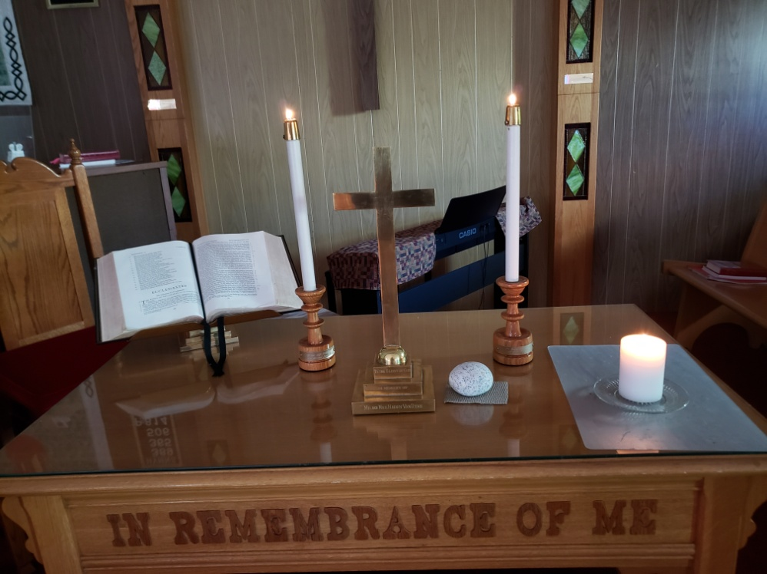
Come, all who are broken-hearted, all who are oppressed, all who are afraid, all who hunger and thirst, all who rejoice, all who celebrate, all who are healing, all whom the world counts as last and least. Come, you are all welcome here. God created a wide world of welcome, filled with good things, with food and drink for all beings. God nurtured a wide world of welcome, and provides a table of welcome for the universe: a loaf of bread, a loaf of life, a loaf of compassion - a loaf to strengthen, nourish and sanctify. A cup of water, a cup of sacrifice, a cup of covenant - a cup to renew, refresh and make whole. As we gather at the table, we proclaim our praise and thanksgiving for God’s great love and mercy.
Gracious God, hear us as we lift up our loved ones and our concerns in prayer. We pray for the church and its varied ministries, its communities of faith and its leaders – especially today St Paul’s UC Thunder Bay, Porcupine UC, St. Andrew’s by the Sea – South Baymouth.
We pray for our own faith communities who share in summer worship. May each person, and their loved ones, enjoy a summer that brings refreshment and renewal. We pray for the safety and wellbeing of all, especially those named in prayer, and those named only in our hearts, and those whose concerns are known only to You, gracious God. Keep us faithful until we gather once more.
We pray for the world, neighbours and strangers, for all who struggle to make ends meet, all who suffer illness and its effects on body and soul, all who are lonely, all who need safe drinking water and refreshing rains to grow crops. We pray for our scientists in every field of endeavour, and for those who tend to our safety and well being in fields of medicine, government, community service.
We pray for people in places of power, that in their decision-making they would exercise holy manners, and offer leadership that is just and fair to all people.
We pray for ourselves, in our times of growing weary, in our times of uncertainty about the future. Keep us ever mindful of your presence with us in all life’s circumstances.
Bless us, and hear us as we pray the prayer of Jesus.
The Lord’s Prayer
Hymn: “In Christ There Is No East or West”* (VU 606)

In Christ there is no east or west, in him no south or north, but one great family of love throughout the whole wide earth.

In him shall true hearts everywhere their high communion find; his service is the golden cord close binding human-kind.

Join hands, then, people of the faith, whate’er your race may be; all children of the living God are surely kin to me.

In Christ now meet both east and west; in him meet south and north; all Christ-like souls are one in him throughout the whole wide earth.

Benediction:
Go to serve God with grace and strength. Go confidently and unafraid. And may the God who created you in love, the Christ who redeems you, and the Spirit who is our helper – go with you, wherever your journey may lead. Amen.
Choral Response: Let Us Praise the God of Truth * (VU 237)
Let us praise the God of truth, let us praise the God of peace, let us praise the God of love. Amen. Hallelujah, Hallelujah, Hallelujah, Amen.
(*hymns in the public domain)

